
A 2 Week Internship program designed to help you understand and appreciate those in need through understanding series; to provide knowledge in the area of social concern through talks; and to expose and experience the work of a social worker in different areas through home attachments.

(Subject to Change)
ATTACHMENT TO:
Urban Poor Children School  Recycle Centre | Old Folks Home  Breakthrough Natural Farming
UNDERSTANDING SERIES:
Marginalized People  Jambatan Anak Malaysia (J.A.M.) | Creation Care  Urban Poor
TALKS ON:
Current Social Issues in Malaysia  Christian Response to SW  Opportunities for Involvement  Reality of Social Worker  Heart & Mind of Christian Worker | Evil & Sin  Church in Society  Framework of Social Work  Social Discrimination  The Person of Nehemiah

YOU might have heard, seen or been involved in social work… yet you are not sure whether this ministry is for you. With a big of curiosity in mind and a great sense of adventure, SWEEP allows you to explore and understand the professional social work. As you learn to embrace it, may it leave deep imprints in your life!

Emergency Contact
Name : …………………………………………………………….....
H/P no:……………………… Relation: …………………………

Church
During Semester : …………………………………………..
Home Church : …………………………………………..

I’ve Been a Christian for : ……………… Years
Any previous involvement in Social Work? (Yes/No)

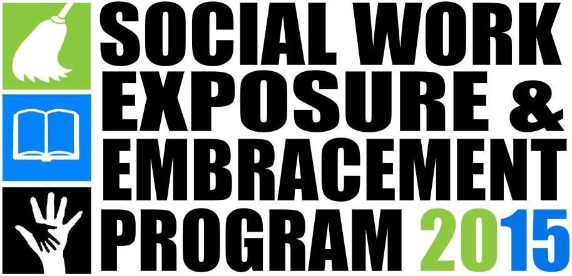



Kindly Send Your Application & Enquiries to:
FES Staff in your Christian Fellowship (CF) or
Jane Jinap (019-886 8137/jane@fes.org.my)
or Richard (012-299 5080/richard@fes.org.my)

Brought to You By:
Fellowship of Evangelical Students (FES) Malaysia

Application Form
Closing Date: 4th May 2015
Sarawak: 15th May

Name : ……………………………………………………………
I.C. No : ……………………………………… Sex: (M/F)
H/P no: ………………………………………
University/College: ………………………………………….
Course/Year : …………………………………………
E-Mail : ……………………………………………………………

Non-Refundable Deposit of RM50 Tick √

